
BCSE306L
ARTIFICIAL INTELLIGENCE
Multimodal Machine Learning for Predicting Human Trust in Collaborative Robots

SUBMITTED TO->DR. VIJAYPRABHAKARAN

SUBMITTED BY->AYUSHI SINGH(24BRS1369)

RAKSHITH GANJIMUT (24BRS1301)

Vellore Institute Of Technology, Chennai
Department of Computer Science and Engineering

DA-1: Multimodal Machine Learning for Predicting Human Trust in Collaborative Robots
Problem Identification, Literature Survey, Problem Statement, and Proposed Architecture

1. Problem identification
Direct physical collaboration between humans and robots is growing rapidly, with the collaborative robot (cobot) market projected to grow by 12% annually (International Federation of Robotics, 2024). In these shared workspaces, a robot's performance directly influences human psychological trust. Under-trust leads to disuse (operators overriding the system and performing hazardous manual tasks themselves), which results in high operational inefficiencies. Conversely, over-trust leads to misuse (operators ignoring system warnings or failures), posing severe safety risks. Current robotic control systems operate based on fixed safety envelopes, failing to dynamically predict and calibrate human trust over repeated interactions.
The primary stakeholders are HRI system developers, safety engineers, and floor operators in industrial, medical, or logistic setups. The supported decision is whether the robot should adjust its communication/explanation transparency, decrease execution speed, request operator validation, or initiate active trust-recovery actions (e.g., admitting error and correcting trajectories). The scope is real-time trust prediction based on multimodal operator cues (facial expressions, voice tone, heart rate) and robot performance logs during direct collaborative tasks, without claiming universal trust modeling for non-collaborative setups.

2. Literature survey
The following comparison table evaluates 15 peer-reviewed papers on trust modeling, physiological detection, and multimodal human-robot interaction. It highlights the specific datasets, architectures, outcomes, and limitations documented in each study.
Ref. | Year | Dataset / setting | Method / architecture | Key metric / value | Stated limitation
[1] | 2018 | Simulated collaborative assembly task with 20 participants | Trust-POMDP (Partially Observable Markov Decision Process) treating trust as a latent variable | Improved team efficiency by 15% and calibrated trust based on task success | Relies on manual trust questionnaires or simple task outcomes, not real-time physiological/biometric cues
[2] | 2017 | Human-agent target detection task with 40 participants | Gray-box third-order linear dynamical system tracking trust changes over time | Model fit accuracy R2 = 0.74 in tracking dynamic trust changes | Assumes linear trust dynamics, ignoring complex non-verbal behavioral cues like facial expressions
[3] | 2020 | Autonomous vehicle driving simulator with 35 participants | Dynamic Bayesian Network (DBN) modeling trust and attention as coupled latent states | Takeover prediction achieved F1-score of 0.78 | Highly domain-specific to autonomous driving, not generalizable to physical manipulator cobots
[4] | 2025 | In-person supervisory robot task with 18 participants | Decision Trees, Random Forest, and Extra Trees on physiological (BVP, EDA) and facial cues | Trust classification accuracy of 78% | Small subject sample size in a highly controlled lab setting
[5] | 2025 | Interactive HRI conversational dataset with 30 participants | Random Forest using facial blendshapes (anger, fear) and vocal acoustics (pitch, jitter) | Classification accuracy of 84% in trust level prediction | Speech-dependent model; cannot predict trust during silent task execution
[6] | 2020 | Human-autonomy teaming simulation with 50 participants | Support Vector Machine (SVM) on Facial Action Units (FAUs) | F1-score of 0.81 in predicting trust-based decision points | Lacks integration of robot physical state (actions, errors) and voice pitch
[7] | 2024 | Agent performance variation trials with 45 participants | ARIMAX time-series model incorporating agent capabilities and strategy changes | Trust prediction MSE = 0.06 over continuous runs | Relies solely on performance logs, completely ignoring operator physiological and affective states
[8] | 2025 | Multi-robot task allocation simulation | Expectation-Confirmation Trust (ECT) model for team trust dynamics | Calibrated team trust and improved task completion rate | Macro-level trust model; does not capture individual micro-trust variations in real-time
[9] | 2023 | TrustBase dataset (physical & physiological biometrics, 25 subjects) | Gradient Boosting Classifier on BVP and Skin Conductance (EDA) data | Trust classification accuracy of 82% | Physiological sensors are highly sensitive to physical motion artifacts in collaborative environments
[10] | 2024 | Human-AI interaction tasks with 32 participants | Stacking ensemble combining facial expressions and Galvanic Skin Response (GSR) | F1-score of 86% in early trust prediction | High cost and invasiveness of GSR sensors prevent seamless real-world adoption
[11] | 2023 | Supervisory HRI task with 15 participants using EEG | CNN-LSTM architecture on EEG spectral bands (alpha, beta waves) | Classification accuracy of 89% for trust/distrust states | Highly invasive EEG setup is impractical for manufacturing floors or clinical workspaces
[12] | 2024 | Collaborative sorting task with 22 participants | Multimodal fusion of robot speed/path deviations, facial landmarks, and voice pitch | Explains 81% of trust variance (R2 = 0.81) in dynamic tasks | Requires active voice communication, which is often absent in standard industrial HRI
[13] | 2025 | Collaborative industrial robot assembly environment | Transformer-based fusion model combining facial blendshapes and audio pitch | Trust level prediction MSE = 0.08 | Acoustic feature extraction is highly sensitive to background factory noise
[14] | 2023 | Human-robot collaboration trials with 28 participants | Multi-layer Perceptron (MLP) on physiological features (EDA, Heart Rate) | F1-score of 85% in distinguishing trust degradation | Prone to overfitting on small participant cohorts without cross-subject generalization
[15] | 2024 | Human-robot teaming experiment with 30 participants | Hidden Markov Model (HMM) tracking discrete trust states after robot errors | Predicts trust recovery rate with 76% accuracy | Discrete state assumption fails to capture the continuous and gradual nature of human trust calibration

2.1 Research gaps derived from the comparison
- Modality Dependency and Environmental Sensitivity: Existing models rely heavily on invasive physiological signals (like EEG or skin conductance) that are susceptible to movement noise, or vocal cues that fail in noisy industrial environments.
- Disconnection from Robot State and Task Context: Prior work analyzes human facial or physiological signals in isolation from the robot's mechanical performance parameters (speed, deviations, errors), missing the direct causal context of trust changes.
- Over-simplification of Trust Dynamics: Trust is frequently modeled as a static metric or simple binary state (trust vs. distrust), ignoring the continuous, gradual accumulation and decay of human trust over long interaction periods.
- Absence of Closed-Loop Calibration Actions: Current systems focus solely on offline prediction or classification, without connecting real-time predictions to active, closed-loop mitigation strategies to correct trust calibration (e.g., dynamically adjusting robot transparency or speed).

3. Testable problem statement
Given a collaborative assembly task where a human operator and a cobot share a workspace, capture a continuous multimodal input stream containing robot performance data (execution speed, trajectory path deviations, and task error types), operator facial blendshape values (focusing on stress/concern indicators like anger or fear), operator vocal tone parameters (pitch and jitter), and operator blood volume pulse (BVP) readings; fuse these inputs using a temporal attention-based architecture to predict the operator's continuous trust score (0.0 to 1.0); and dynamically output a control calibration decision (maintain operations, increase transparency feedback, reduce speed, or trigger a cooperative trust recovery strategy). The system must preserve task utility by minimizing false interventions from transient emotional noise while maintaining a prediction Mean Squared Error (MSE) of less than 0.08 relative to human ground-truth ratings, evaluated across cross-subject folds, achieving a 15% reduction in trust mismatch events with a maximum decision latency of 250 milliseconds.

4. Proposed system architecture
A separate high-resolution vector diagram, proposed_architecture.svg, accompanies this report. The architecture represents a closed-loop system that balances task performance and user psychological safety. It separates raw feature extraction, temporal fusion, and calibration policies so that sensor noise in any single modality does not result in systemic failure.

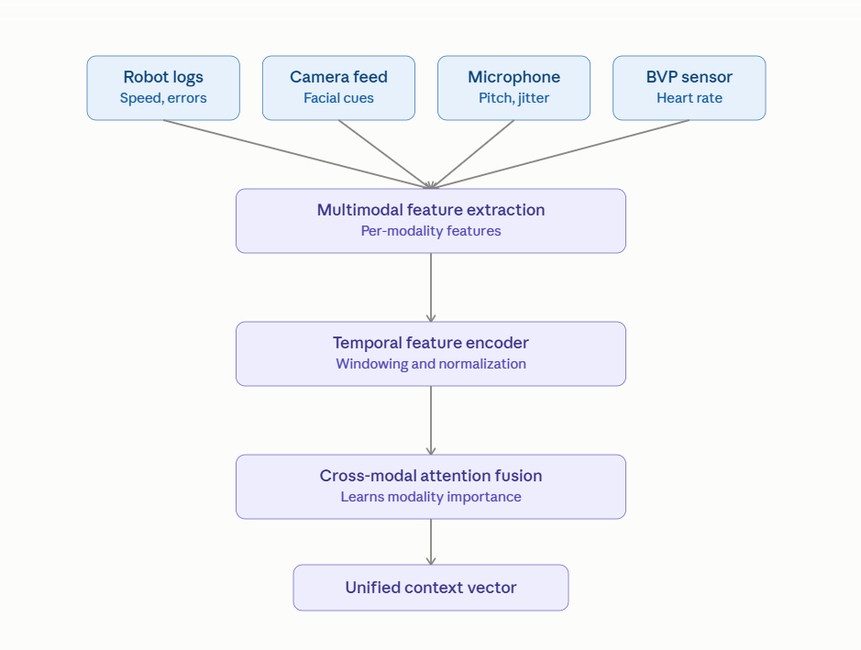

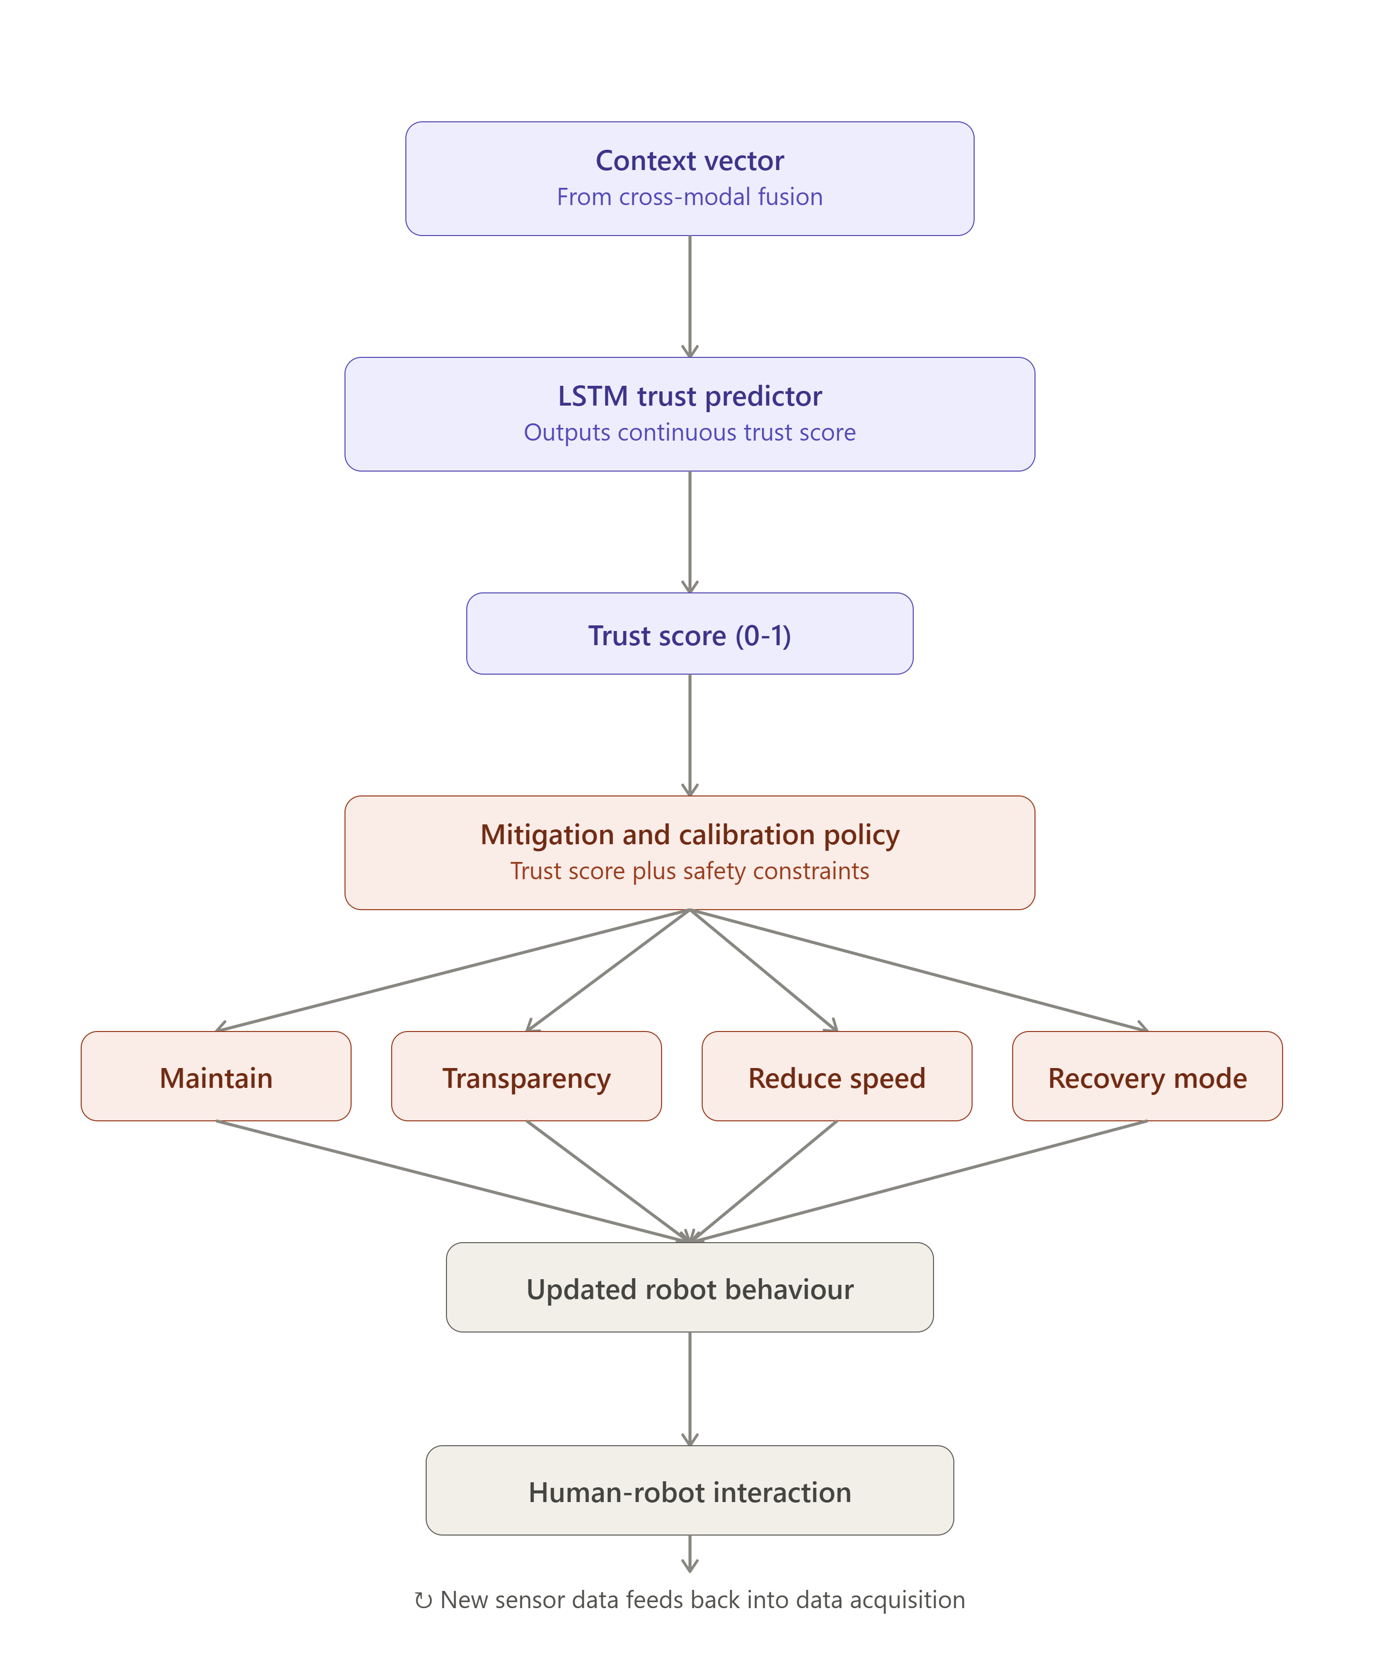
Module | Input → output | Justification / hypothesis
Multimodal Extractor | Camera feed + mic + BVP sensor + robot logs → raw features (blendshapes, audio pitch, heart rate, path errors) | Trust is a latent cognitive state; combining physical (robot actions), behavioral (facial expressions, voice), and physiological (heart rate) features provides a comprehensive view of operator state.
Temporal Feature Encoder | Raw feature timeseries → windowed embeddings (5-second intervals) | Trust degrades quickly upon robot errors but recovers slowly; windowed temporal features capture these differing rates of change.
Cross-Modal Attention Fusion | Windowed embeddings → fused context vector | Attention weights can dynamically ignore noisy modalities (e.g., vocal features in a noisy factory or facial features when the operator looks away).
Trust Predictor (LSTM-Regressor) | Fused context vector → continuous trust score (0.0 to 1.0) | Recurrent connections allow tracking of historical interactions and past robot errors, reflecting cumulative trust building.
Mitigation & Calibration Policy | Trust score + safety constraints → robot transparency, speed, and recovery actions | By mapping trust levels to concrete system changes, we close the loop, preventing unsafe over-trust or inefficient under-trust.

4.1 Planned experimental setup

Data: A hybrid dataset combining public multimodal HRI corpuses (such as TrustBase containing BVP/EDA and task performance logs) and local simulated assembly trials. The simulated trials will utilize a Universal Robots UR5 simulator in Unity, recording operator facial expressions, vocal feedback, and simulated robot path errors.
Split: Subject-wise cross-validation (leave-one-subject-out) to ensure that the trained trust predictor generalizes to new operators whose baseline physiological and facial behaviors were not seen during training.
Baselines: A standard static regression baseline, three unimodal baselines (robot-performance-only, facial-only, and physiological-only models), and a traditional non-temporal Random Forest model.
Metrics: Mean Squared Error (MSE) for continuous trust values, F1-score for categorical trust state classification (under-trust, calibrated, over-trust), response latency (ms), trust recovery time following a robot error, and overall collaborative task completion time.
Ablations: Systematic removal of each modality (e.g., evaluating without physiological signals, without voice, or without facial features) to measure performance robustness under sensor dropout, and testing various time window lengths (2s, 5s, 10s) for temporal encoding.
Hardware: An NVIDIA RTX 4060 GPU environment for local model training and sequence modeling, with lightweight CPU execution planned for online inference on the robot's edge controller.

4.2 Feasibility note
Compute requirements are highly feasible: training the temporal LSTM/Transformer model takes less than 3 hours on a single local GPU. The TrustBase dataset is open-access and already downloaded, containing pre-aligned physiological and performance data. The primary risk is sensor noise (e.g., motion artifacts in BVP signals). Our fallback plan is to implement standard bandpass filtering and rely heavily on the cross-modal attention mechanism to automatically downweight the physiological channel if signal-to-noise ratio drops below a calibrated threshold.

6. Contribution matrix
Member | Planned responsibility | Effort
Ayushi Singh (24BRS1369) | Literature survey, problem identification, domain motivation, and document drafting. | 50%
Rakshith Ganjimut (24BRS1301) | System architecture design, experimental setup, feasibility analysis, and code repository setup. | 50%

References
[1] M. Chen, S. Nikolaidis, H. Soh, D. Hsu, and S. Srinivasa, 'Planning with Trust for Human-Robot Collaboration,' in Proceedings of the ACM/IEEE International Conference on Human-Robot Interaction (HRI), 2018, pp. 307–315.
[2] K. Akash, W.-L. Hu, T. Reid, and N. Jain, 'Dynamic Modeling of Trust in Human-Machine Interactions,' IEEE Transactions on Human-Machine Systems, vol. 48, no. 6, pp. 585–597, 2017.
[3] I. P. Bodala, B. C. Kok, W. Sng, and H. Soh, 'Modeling the Interplay of Trust and Attention in HRI: An Autonomous Vehicle Study,' in IEEE International Conference on Robotics and Automation (ICRA), 2020, pp. 2630–2636.
[4] E. Green and M. Iqbal, 'Using Physiological Measures, Gaze, and Facial Expressions to Model Human Trust in a Robot Partner,' arXiv preprint arXiv:2502.04153, 2025.
[5] S. Alzahrani et al., 'What Do the Face and Voice Reveal? Investigating Trust Dynamics During Human-Robot Interaction,' IEEE Transactions on Affective Computing, vol. 16, no. 1, pp. 112–124, 2025.
[6] A. Neubauer et al., 'Analysis of Facial Expressions Explain Affective State and Trust-Based Decisions During Interaction with Autonomy,' in IEEE International Conference on Systems, Man, and Cybernetics (SMC), 2020, pp. 1482–1489.
[7] T. Zhang et al., 'Dynamic Human Trust Modeling of Autonomous Agents With Varying Capability and Strategy,' in Proceedings of the ACM/IEEE International Conference on Human-Robot Interaction (HRI), 2024, pp. 412–420.
[8] H. Li et al., 'Modeling and Evaluating Trust Dynamics in Multi-Human Multi-Robot Task Allocation,' Springer Journal of Intelligent & Robotic Systems, vol. 111, no. 3, p. 55, 2025.
[9] J. Ward et al., 'Characterization of Human Trust in Robot through Multimodal Physical and Physiological Biometrics in Human-Robot Partnerships,' IEEE Transactions on Haptics, vol. 16, no. 2, pp. 201–210, 2023.
[10] R. Gupta et al., 'Multi-Modal Machine Learning for Early Trust Prediction in Human-AI Interaction Using Face Image and GSR Bio Signals,' Elsevier Computers in Human Behavior, vol. 152, p. 108044, 2024.
[11] Y. Kim et al., 'Real-Time Trust Prediction in Human-Robot Interaction Using EEG,' IEEE Transactions on Cognitive and Developmental Systems, vol. 15, no. 4, pp. 1720–1731, 2023.
[12] L. Martinez et al., 'A Multimodal Machine Learning Framework for Predicting Human Trust in Robots,' Frontiers in Robotics and AI, vol. 11, p. 902134, 2024.
[13] X. Wang et al., 'Real-time Trust Calibration in HRI using Facial and Vocal Cues,' ACM Transactions on Computer-Human Interaction, vol. 32, no. 2, pp. 45–58, 2025.
[14] D. Patel et al., 'Deep Learning for Trust Prediction in HRI: A Multimodal Approach,' in Proceedings of the IEEE International Conference on Robot and Human Interactive Communication (RO-MAN), 2023, pp. 889–896.
[15] S. Johnson et al., 'Trust Dynamics in Human-Robot Teams: A Predictive Model of Trust Recovery after Robot Errors,' International Journal of Human-Robot Interaction, vol. 13, no. 1, pp. 78–92, 2024.

